NCDMPH Lesson Design Document
Draft 5/9/13

Contents
Purpose 2
Project Target Audience 2
Project Delivery & Functionality 2
Terminology 2
File Formatting 2
File-Naming Scheme 3
Proposed Lesson Design 5
Basic Text/Graphic Screen 5
Knowledge Check Screen 6
Functionality/Interactivity 6
Knowledge Checks 7
In the Field 7
Resources Button 7
Take Aways 7
Text Expands or Click Graphics 7
Print or Share 7
Storyboard Templates 8

Purpose
This document is intended as a reference for style and formatting elements, as well as guiding decisions, made for the development of two learning objects for the NCDMPH. As such, the document shall evolve with the project, will be occasionally updated and will be provided to all stakeholders when updated.

Project Target Audience
The target audience for the two learning objects (lessons) under development is a full range of health care providers who may encounter children. Upon approval by accrediting authorities, each lesson will be available for CME credit by authority of various associations and agencies. Learners may access the lessons with a variety of intentions: to gain accreditation, to acquire a general understanding of the material for eventual application or research, or to quickly recall/access information needed for immediate reference.

Project Delivery & Functionality
Each lesson shall be delivered in online format, coded in HTML 4.0 for compatibility on all major browsers and accessibility via desktop and mobile browsers. Functionality will be limited to that allowed under 508 compliance standards and on desktop and mobile platforms.

Terminology
Each of the two NCDMPH learning objects shall be referenced within the object as a “lesson.” Any further subsection of a lesson shall be referenced as a “module.”

File Formatting
All graphics files will be provided in PNG format: tables, figures and photo images, as well as interface graphics.
Storyboards will be provided in MSWord format. Track changes will be used to monitor changes to storyboards during review.

File-Naming Scheme
For each lesson of the NCDMPH curriculum, we shall assign storyboard page numbers/filenames and graphic numbers/filenames using the following guidelines.

Storyboard Screen Names for Lessons
Storyboard Page Numbering Logic | The first two characters in the name string indicate the organization name.  NC_  The next two characters in the name string indicate the lesson name. Use the following key:  Psychosocial Impacts = PI  Radiation Issues = RI  NC_PE or NCDM_RI  The next 3 characters indicate the topic number. Topics are the main sections of the lesson (level 1 heads in the outline). Most topics include 2 or more sections.  NC_PI_T01 = topic 1 (Introduction) of the NCDM Pyschosocial Effects lesson  The next three characters indicate the screen number. We are going to number the screens in increments of 10 to allow for insertion/deletion of boards throughout the review process (in other words, they’ll go from 10 to 20 to 30, etc.).  So for the course titled “Psychosocial Impacts,” the first screen of lesson 1 would be named: NC_PI_T01_010  The next screen would be named: NC_PI_T01_020  And so on.
Storyboard Filenames: Versioning of Storyboards
Storyboard Files will be named according to the above convention, with the addition of dates and initials for version control (possibly even version#).
For example, the storyboard file for version 1 of Psychosocial Impacts delivered on May 24, 2013 by Mollie McCormick would be called NC_PI_052413v1_MMc.docx

Graphic File Names: Interface Graphics
Graphics created for the GUI will be named with the organizational characters, followed by a logical shortened name for the graphic. All graphic filenames will be lowercase.

For example, the Next button used throughout the lessons will be titled: nc_next.png

Graphic File Names: Inline Graphics
Within this program, we will have graphics for nearly every page, including photos, tables, and figures. The media file names will be based on the location where they are used. All graphic filenames will be lowercase.
- For example, a graphic that it is used on the 3rd page of the module titled, “Psychosocial Impacts” would have this name: NC_PI_030
(We will not label the media element as a .png or .pdf in the storyboard references — just write the name.)

If a screen requires more than one media file, we only need to add a lower case letter at the end of the name for both graphics.
- For example, if we need to use two graphics on the 3rd page of the module titled, “Psychosocial Impacts” they would be named as follows:
NC_PI_030a and NC_PI_030b

Proposed Lesson Design
Following is a draft concept of the proposed lesson design and layout. Views are presented showing a typical text/graphic page with footnotes and TOC and a proposed Knowledge check screen with graphic. The design intentionally mimics the recognizable basic layout of the NCDMPH website, using color (green) and a distinct header to identify the lesson as part of the NCDMPH Learning initiative “brand.” When standing on its own as a lesson provided through any Learning Management System – internally or externally – the lesson can be easily identified as part of the larger “Knowledge & Learning” aspect of the NCDMPH mission. Direct links to the NCDMPH website are provided below the TOC for the lesson.
Functionality and potential interactions are described in a section below the graphics.

Basic Text/Graphic Screen

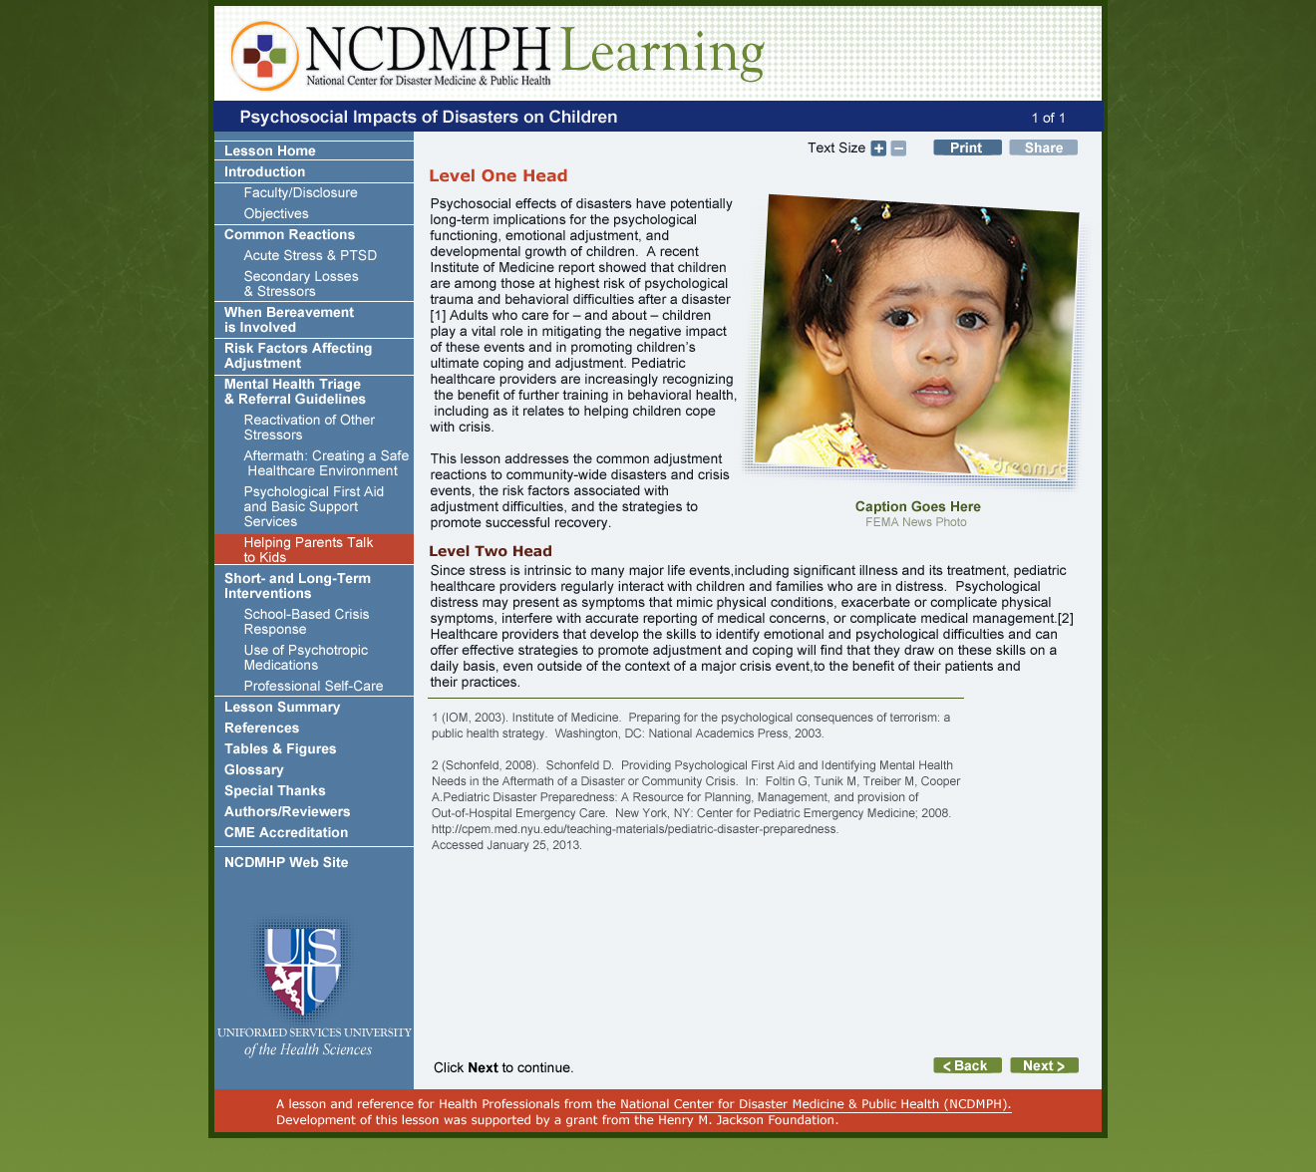

Knowledge Check Screen
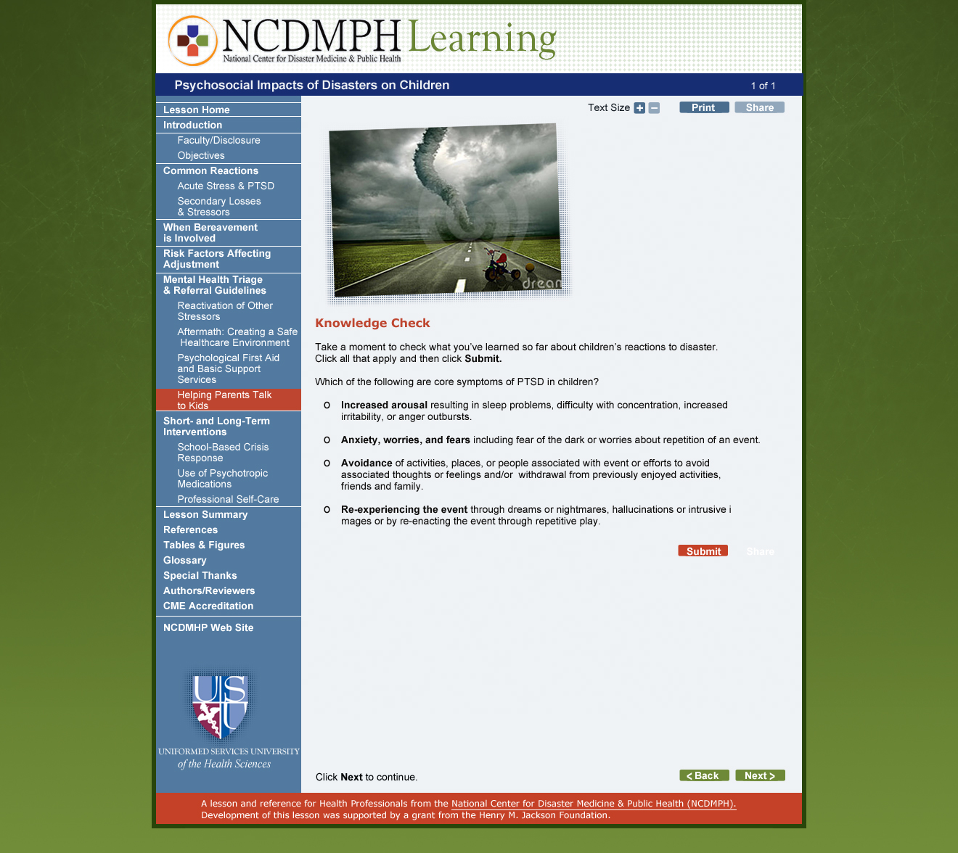

Functionality/Interactivity
Research shows that interactivity is key to learners recalling and retaining information in any course; therefore, efforts will be made to incorporate interactivity into the NCDMPH lessons wherever possible, despite constraints of 508 compliance and multi-platform delivery.
Features of the lessons should contribute to the multi-purpose use of the lessons, for accreditation, general knowledge or immediate reference. Proposed interactions and functionality that may support this effort are outlined briefly below.

Knowledge Checks
To aid in recall throughout the lessons, periodic Knowledge Checks may be inserted. These will typically come at the end of a topic and take the form of multi-choice or single choice answers (including True/False) and will provide feedback for correct or incorrect answers, including referral to any pertinent resources.

In the Field
Vignettes or case studies will be presented as “In the Field” stories at intervals in the text to illustrate points made in the text. These will take the form of a photo and text description or video with text introduction.

Resources Button
Potential exists for use of a Resource button that will appear on the page to allow learners to quickly access tables, figures or other take-away resources that are of value. Placement and usage of the button to be determined – it could be included at the top of every page to give quick access to the complete Resources list at any time (although a text link exists in the TOC, the button is more helpful to mobile users).

Text Expands or Click Graphics
Either of these two methods may allow for increased interaction with the text of the lesson. With a Text Expand, a learner is prompted to click a series of statements to expand the statement and reveal more details. We recommend that a whole (brief) statement be shown as a button (with + sign) to enable easier access (larger field to click on) on mobile devices.
With a Click Graphic the learner is prompted to click one or more small images (e.g., photos) on a page to reveal and review text in a text area below the image(s).

Print or Share
The Print button allows learners to download a printout of the current page. An optional Share button may be included to allow learners to email the page to themselves or a colleague (button brings up a form with email fields and comment area). A further option for the Share feature might be to allow learners to share via social media (the button brings up options to share via Facebook, LinkedIn, Pinterest). This is open for discussion.

A sample of a Facebook Like/Share bar.

Storyboard Templates
Following are sample storyboard templates used in the storyboard layout.
Lesson Name: Psychosocial Impacts of Disasters on Children | Topic Name: ????
Storyboard: ???? | Template: [TextOnly]
Screen Title: ????
On–Screen Text:

This storyboard has only text. There may be bulleted text like so:

Bullet item 1
Bullet item 2
Bullet item 3

And some more text

Footnotes:

Screen Prompt: Click Next to continue.
Programmer Notes / Interactions & Feedback:
This screen contains text.
Permissions Notes:

Lesson Name: Psychosocial Impacts of Disasters on Children | Topic Name: ????
Storyboard: ???? | Template: [TextGraphic]
Screen Title: ????
On–Screen Text:
Lorem ipsum dolor sit amet, consectetur adipiscing elit. Sed lacinia ultrices lectus nec facilisis. Curabitur interdum elementum commodo. Duis rhoncus, elit a dictum condimentum, ante odio mattis risus, vitae molestie velit justo eu dolor. Donec ultricies ante quis arcu tincidunt interdum. Morbi enim eros, convallis a elementum sed, cursus non mi. Cras in erat turpis, vel bibendum orci. In a nisl et nisi dignissim sagittis nec vel lectus. In hac habitasse platea dictumst. Quisque non consectetur nisi. Integer egestas sollicitudin tempus.
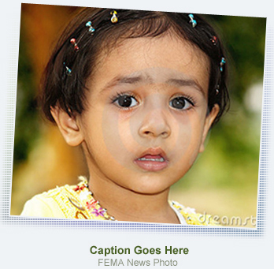
Suspendisse lorem purus, suscipit ut sollicitudin et, volutpat vitae libero. Nullam lacinia rhoncus sapien non vulputate. Sed luctus libero massa, in aliquet enim. Sed tempor, mauris vel ornare interdum, velit est semper arcu, nec porta eros risus eget felis. Suspendisse tincidunt, velit interdum dictum dapibus, nibh turpis facilisis nisi, a hendrerit augue magna id nunc. Pellentesque eget justo augue. Morbi mattis lacinia sem, eget tristique enim vehicula sit amet.
- Vivamus nec est non elit consectetur pulvinar.
- Maecenas imperdiet augue pharetra quam sollicitudin lacinia.
- Praesent quis quam massa, nec ullamcorper nulla.
Footnotes:

Graphic = photo
?????

ALT tag:
alt="close up photo of very young girl, wide-eyed and sad"

Photo caption: This is a caption; it has no period Photo credit: FEMA News Agency
Screen Prompt: Click Next to continue.
Programmer Notes / Interactions & Feedback:
This screen contains text and a graphic (photo, figure or table). Figures & tables will be wide, so they will go below any text. Photos are box or portrait orientation; they will either be right-aligned with the text or centered above the text.

All photos should be padded by 5px all around. Not all photos will have captions or credits (credits only for those required – purchased stock photos do not require credit). All images should have an ALT text tag.

Lesson Name: Psychosocial Impacts of Disasters on Children | Topic Name: ????
Storyboard: ???? | Template: [ClickGraphic]
Screen Title: ????
On–Screen Text:
Intro text Lorem ipsum dolor sit amet, consectetur adipiscing elit. Sed lacinia ultrices lectus nec facilisis. Curabitur interdum elementum commodo. Duis rhoncus, elit a dictum condimentum, ante odio mattis risus, vitae molestie velit justo eu dolor. Click each photo to discover X or learn more.
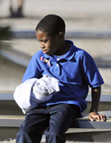
[ClickGraphicText1]
Suspendisse lorem purus, suscipit ut sollicitudin et, volutpat vitae libero. Nullam lacinia rhoncus sapien non vulputate. Sed luctus libero massa, in aliquet enim. Sed tempor, mauris vel ornare interdum, velit est semper
[ClickGraphicText2]
Sed luctus libero massa, in aliquet enim. Sed tempor, mauris vel ornare interdum, velit est semper arcu, nec porta eros risus eget felis. Suspendisse tincidunt, velit interdum dictum dapibus, nibh turpis facilisis nisi, a
Graphic = photo
?????

ALT tag:
alt=" "

Photo caption: This is a caption; it has no period Photo credit: FEMA News Agency
Screen Prompt: Click each photo to learn more. Click Next to continue.
Programmer Notes / Interactions & Feedback:
This screen contains text and 1-3 graphics (photos). There may be introductory text before the photos. Photos are box or portrait orientation; they will be center-aligned with the text and padded by 5px all around. Not all photos will have captions or credits (credits only for those required – purchased stock photos do not require credit). All images should have an ALT text tag.

When the learner clicks a graphic, associated text (noted as [ClickGraphicText#]) displays under both graphics.

If possible, code to require learner to click both graphics (reveal all text) before clicking Next.

Lesson Name: Psychosocial Impacts of Disasters on Children | Topic Name: ????
Storyboard: ???? | Template: [ClickExpand]
Screen Title: ????
On–Screen Text:
Intro text Lorem ipsum dolor sit amet, consectetur adipiscing elit. Sed lacinia ultrices lectus nec facilisis. Curabitur interdum elementum commodo. Duis rhoncus, elit a dictum condimentum, ante. Click each statement to learn more.
[+ This is a statement in button form that can be clicked to show details]
This is the additional text, which will only be revealed after the learner has clicked the statement above. Each statement will remain expanded after being clicked.
[+ This is a statement in button form that can be clicked to show details]
This is the additional text, which will only be revealed after the learner has clicked the statement above. Each statement will remain expanded after being clicked.
[+ This is a statement in button form that can be clicked to show details]
This is the additional text, which will only be revealed after the learner has clicked the statement above. Each statement will remain expanded after being clicked.
Footnotes:

Screen Prompt: Click each statement to reveal details. Click Next to continue.
Programmer Notes / Interactions & Feedback:
This screen contains text statements that, onClick, will reveal additional text below each statement. Once revealed, the text will remain revealed (until the learner leaves and returns to the page). The statements will be brief and coded as “buttons” so that they are easy to open on a mobile device. Each statement will be preceded by a + sign.

When the learner clicks a statement, associated text with display under the statement.

Lesson Name: Psychosocial Impacts of Disasters on Children | Topic Name: ????
Storyboard: ???? | Template: [MultiChoice]
Screen Title: ????
On–Screen Text:

Knowledge Check
This is some Introductory text for a multiple choice question. (Select all that apply.)
- Question 1
- Question 2
- Question 3
- Question 4
- Question 5
Submit

Feedback:

[CORRECT]
This is feedback for correct statements checked off.

Click Next to continue.

[INCORRECT]
This is feedback for correct statements checked off.

Select all that apply, then click Submit. Click Next to continue.
Screen Prompt: Check all statements that apply, then click Submit. Click Next to continue.
Programmer Notes / Interactions & Feedback:
This screen contains text statements (in checkboxes) that the learner must check to indicate their agreement with. OnSubmit feedback is displayed below the Question and their responses.

If 4 or more statements are checked (any 4), show CORRECT feedback. If 3 or less are checked, show the INCORRECT feedback. Feedback may be correct or incorrect or may simply be one statement (“If you selected ALL of the statements, then X, and if you selected 2 or fewer statements then Y.”

Lesson Name: Psychosocial Impacts of Disasters on Children | Topic Name: ???
Storyboard: ??? | Template: [SingleChoice]
Screen Title: ???
On–Screen Text:

Knowledge Check
This is the Question Stem; it may be a single select answer to a question or a True/False question.
- True
- False [CORRECT]
Submit

Feedback:

[CORRECT]
Yes, this statement is false. Research evidence has not been shown to warrant the use of CISD (or CISM) for healthcare professionals; some studies have actually shown such approaches to be detrimental. Practices that mitigate stress include having a family disaster plan, maintaining brief communications among colleagues, and fostering a culture of acceptance that normalizes asking for and accepting assistance, encouraging members to take active steps to care for colleagues and themselves.

[INCORRECT]
No, this statement is false. Research evidence has not been shown to warrant the use of CISD (or CISM) for healthcare professionals; some studies have actually shown such approaches to be detrimental. Practices that mitigate stress include having a family disaster plan, maintaining brief communications among colleagues, and fostering a culture of acceptance that normalizes asking for and accepting assistance, encouraging members to take active steps to care for colleagues and themselves.
Screen Prompt: Select your answer, then click Submit. Click Next to continue.
Programmer Notes / Interactions & Feedback:
This screen contains a true/false statement that the learner must respond to. OnSubmit feedback is displayed below the Question and their response.

Lesson Name: Psychosocial Impacts of Disasters on Children | Topic Name: ????
Storyboard: ???? | Template: [TextVideo]
Screen Title: ????
On–Screen Text:
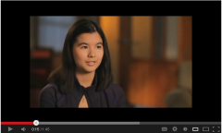
Lorem ipsum dolor sit amet, consectetur adipiscing elit. Sed lacinia ultrices lectus nec facilisis. Curabitur interdum elementum commodo. Duis rhoncus, elit a dictum condimentum, ante odio mattis risus, vitae molestie velit justo eu dolor. Donec ultricies ante quis arcu tincidunt interdum. Morbi enim eros, convallis a elementum
Footnotes:

Video =
embed link: http://www.youtube.com/watch?v=BBHm_L2Fb9k&feature=youtu.be
Screen Prompt: Click Play to watch the video. Click Next to continue.
Programmer Notes / Interactions & Feedback:
This screen contains text and an embedded video. The video will be centered below the text.

