These are the storyboards for the NCDMPH lesson titled ”Psychosocial Impacts of Disasters on Children.”

This lesson includes a title screen and the following topics:

- Title/Faculty
- Disclosures
- Objectives
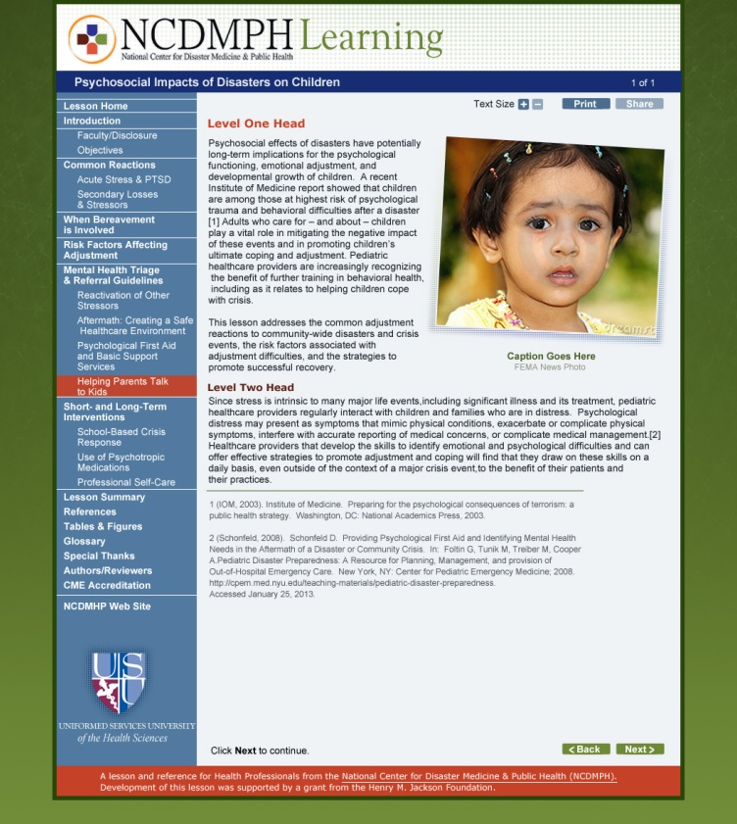
- Introduction
- Children’s Post-Disaster Reactions
- Adjustment Risk Factors
- Reactivation of Stressors
- Fostering Wellness & Recovery
- Professional Self-Care
- Summary
- References & Resources
- Author & Reviewers
- Special Thanks
- CME/CE Credit

General Lesson Navigation

If users just keep clicking “Next,” they should be able to progress through the lesson and all 10 topics, from beginning to end. However, users will also be able to jump from one topic to another with the left-hand side navigation, in which links to the 10 topics will be presented on the left side of the screen.

Left Side Navigation Information

The left side navigation should be visible at all times.

- The Topic Titles (links) in the navigation may be shorter versions of the Page Titles, because of available screen space.
- Each Main Topic in the navigation will be preceded by a line to mark off a new section.
- Once the learner clicks into a Topic, the subsections for the topic should be displayed. The subsections should be displayed as long as the learner remains in a specific topic.

Navigation Branching
Following are the initial screens for each topic of the lesson. (The page numbers shown reference the starting point of each topic in the storyboard document.)

Title/Faculty = NC_PI_T00_010 2
Disclosures = NC_PI_T00_020 4
Objectives = NC_PI_T00_030 5
Introduction = NC_PI_T01_010 6
Children’s Post-Disaster Reactions = NC_PI_T02_010 13
Adjustment Risk Factors = NC_PI_T03_010 34
Reactivation of Stressors = NC_PI_T04_010 40
Fostering Wellness & Recovery = NC_PI_T05_010 45
Professional Self-Care = NC_PI_T06_010 70
Summary = NC_PI_T07_010 75
References & Resources = NC_PI_T08_010 77
Author & Reviewers = NC_PI_T09_010 84
Special Thanks = NC_PI_T10_010 86
CME/CE Credit = NC_PI_T11_010 88

The Title screen (first screen) of the lesson will feature the Facebook and Twitter icons in the upper right of the content area. These Share features will not appear on any other screen in the lesson.

Each screen of the lesson will contain the following buttons:
- [Back] Moves learners back one screen (should be inactive on first screen).
- [Next] Moves learners forward one screen (should be inactive on last screen).
- Text Size: [ + ] [ - ] allows learners to change the font size to enhance readability
- Print allows learners to print the current page

Optional Buttons (appear as indicated in the storyboards):
- [Resource] appears whenever a resource of note is mentioned in the text – this button is present ONLY when a useful resource is presented in the text or is related to the text. These should appear in upper left of the content area, above the breadcrumbs. The button will link as indicated in the storyboards: to a PDF (opens in new window) or to an external website (opens in new window)

Section 508 Considerations

Following are some guidelines that should be followed to ensure improved access for learners using screen readers or similar assistive devices:

- Each graphic or photo should have an ALT tag associated with it.
- Code should be included in each page that directs screen reading devices to “skip” reading the navigation to a learner using the device.

Title/Faculty = NC_PI_T00_010

Lesson Name: Psychosocial Impacts of Disasters on Children | Topic Name: Lesson Home
Storyboard: NC_PI_T00_010 | Template: [TextGraphic]
Screen Title: Title/Faculty
On–Screen Text:
Psychosocial Impacts of Disasters on Children
David J. Schonfeld, MD, FAAP

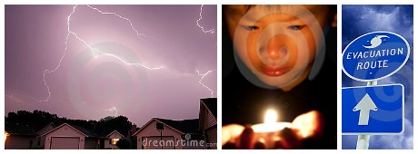
Footnotes: n/a
Graphic:
Graphic = NC_PI_T00_010
ALT tag: alt="Photo collage of a stormy sky, young boy holding a candle with tears in his eyes, and evacuation route sign with stormy sky"
Photo caption: n/a
Photo credit: n/a
Screen Prompt: Click Next to continue.
Programmer Notes / Interactions & Feedback:
This screen contains text and a photo. The photo should be centered on this title screen. The links should open in the same window.

NOTE: This is the first screen of the lesson. In place of Text Resize and Print buttons at the upper right of content area, the Facebook and Twitter icons (providing Share functionality) should appear at upper right.

Lesson Name: Psychosocial Impacts of Disasters on Children | Topic Name: Lesson Home
Storyboard: NC_PI_T00_020 | Template: [TextGraphic]

Screen Title: Disclosures
On–Screen Text:
This continuing education activity is managed and accredited by Professional Education Service Group. The information presented in this activity represents the opinion of the author(s) or faculty. Neither PESG, nor any accrediting organization endorses any commercial products displayed or mentioned in conjunction with this activity.

Commercial Support was not received for this activity.

Neither the author nor any of the reviewers involved in this educational activity have any relevant financial relationships with commercial interests to disclose. (A complete listing of the author and reviewers is available at the end of this activity)

CME Staff Disclosures
Professional Educational Services Group staff have no financial interest or relationships to disclose.
Graphic:
Graphic = NC_PI_T00_020
ALT tag: alt="logo for Professional Education Services Group, A CME Company"

Screen Prompt: Click Next to continue.
Programmer Notes / Interactions & Feedback:
This screen contains text and an inline graphic (logo) -- This logo will likely be smaller than the standard right-size photo.

Lesson Name: Psychosocial Impacts of Disasters on Children | Topic Name: Lesson Home
Storyboard: NC_PI_T00_030 | Template: [TextOnly]

Screen Title: Objectives
On–Screen Text:
After completing this lesson, you should be able to

- describe common adjustment reactions in children exposed to disasters, including the unique ways that bereavement and specific risk factors make adjustment more difficult.

- take steps to create a healthcare delivery environment that anticipates and reduces contributions to child and family distress after a disaster.

- advise parents and other caregivers about supporting children’s recovery after a disaster.
Footnotes:
n/a
Screen Prompt: Click Next to continue.
Programmer Notes / Interactions & Feedback:
This screen contains text.

Introduction = NC_PI_T01_010
Lesson Name: Psychosocial Impacts of Disasters on Children | Topic Name: Introduction
Storyboard: NC_PI_T01_010 | Template: [TextGraphic]
Screen Title: Long-Term Psychological and Social Impacts
On–Screen Text:

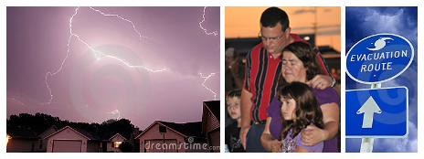

When disaster strikes — whether natural or manmade — lives and communities are permanently altered. Visible damage provides clues to the devastation and loss of life, while news reports progress from grim to hopeful to stories of recovery. Less frequently reported are the lingering psychological and social impacts of disasters on a population.

The psychosocial impacts of disasters have potentially long-term consequences for the psychological functioning, emotional adjustment, and developmental trajectory of children. In fact, an Institute of Medicine report has shown that children are among those at highest risk of psychological trauma and behavioral difficulties after a disaster.[1] Adults who care for – and about – children play a vital role in mitigating the negative effects of these events and promoting children’s ultimate coping and adjustment.

This lesson addresses the common adjustment reactions of children to community-wide disasters and crisis events, identifies risk factors associated with their adjustment difficulties, and describes strategies to promote successful coping and resiliency for children. Because it is important for any successful helping strategy, we also address self-care for healthcare professionals.
Footnotes:
1 Institute of Medicine. Preparing for the Psychological Consequences of Terrorism: A Public Health Strategy. Washington, DC: National Academics Press; 2003.
Graphic = NC_PI_T01_010
Photo collage of a stormy sky, family at I AM JOPLIN event, and evacuation route sign with stormy sky”
Photo caption: n/a Photo credit: n/a
Screen Prompt: Click Next to continue.
Programmer Notes / Interactions & Feedback:
This screen contains text and a graphic aligned to the right of the text.

[Objectives moved to Home topic]
Lesson Name: Psychosocial Impacts of Disasters on Children | Topic Name: Introduction
Storyboard: NC_PI_T01_020 | Template: [TextOnly]
Screen Title: Competencies
On–Screen Text:
If you are using a competency-based approach for your professional development, or participating in this lesson as part of a competency-based education or training program, the following information is provided to assist you in relating this lesson to competency development.
This lesson supports learning related to the following competencies, with regard to psychosocial impacts of disasters on children:*
Core Competencies and Subcompetencies for Disaster Medicine and Public Health by Walsh et al.[2]
Subcompetency 1.4 “Describe methods for enhancing personal resilience, including physical and mental health and well-being, as part of disaster preparation and planning”
Subcompetency 5.2 “Describe risk reduction measures that can be implemented to mitigate or prevent hazardous exposures in a disaster or public health emergency”
Subcompetency 7.1 “Discuss common physical and mental health consequences for all ages and populations affected by a disaster or public health emergency”
Core Competency 8.0 “Demonstrate knowledge of public health principles and practices for the management of all ages and populations affected by disasters and public health emergencies”
Subcompetency 8.1 “Discuss public health consequences frequently seen in disasters and public health emergencies”
Subcompetency 8.2 “Identify all ages and populations with functional and access needs who may be more vulnerable to adverse health effects in a disaster or public health emergency”
Subcompetency 8.3 “Identify strategies to address functional and access needs to mitigate adverse health effects of disasters and public health emergencies”
Subcompetency 8.4 “Describe common public health interventions to protect the health of all ages and populations affected by a disaster or public health emergency”
Subcompetency 11.4 “Discuss the importance of monitoring the mental and physical health impacts of disasters and public health emergencies on responders and their families”[2]
* There are many published competency sets within the field of disaster health. For additional information, see Disaster-related competencies for healthcare providers. Disaster Information Management Research Center, National Library of Medicine [http://disaster.nlm.nih.gov/dimrc/professionalcompetencies.html]
Footnotes:
2 Walsh L, Subbarao I, Gebbie K, et al. Core competencies for disaster medicine and public health. Disaster Med Public Health Prep. 2012;6(1):44-52.
Screen Prompt: Click Next to continue.
Programmer Notes / Interactions & Feedback:
This screen contains text.

Lesson Name: Psychosocial Impacts of Disasters on Children | Topic Name: Introduction
Storyboard: NC_PI_T01_030 | Template: [ClickGraphic]
Screen Title: Addressing a Preparedness Void
On–Screen Text:
Pediatric healthcare providers are increasingly recognizing the benefit of further training in behavioral health, particularly as it relates to helping children cope with crisis.
Click each photo in turn below to discover the value of pediatric behavioral health training for providers, whether during disaster response or every day.
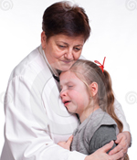
[ClickGraphicText1]
Boosting Disaster Preparedness
Surveys show that nearly 3 out of 4 pediatric healthcare providers feel unprepared to respond to a bioterrorist event and its overall aftermath, including mental health concerns.[3] Most pediatric healthcare providers after Hurricane Katrina reported wanting more help identifying and meeting the mental health needs of their patients,[4] and more recent disaster responders have indicated that this need persists unabated.

[ClickGraphicText2]
Increasing Everyday Awareness
Because stress is intrinsic to many major life events, including significant illness and its treatment, pediatric healthcare providers regularly interact with children and families who are in distress. Through the process known as somatization [NC_PI_T08_040/#soma], psychological distress may present as symptoms that mimic physical conditions, exacerbate or complicate physical symptoms, interfere with accurate reporting of medical concerns, or complicate medical management.[5] Healthcare providers who develop skills to identify emotional and psychological difficulties and can offer effective adjustment and coping strategies will use these skills every day—even outside of a major crisis event—to the benefit of their patients and practices.
Footnotes:
3 Hu Y, Adams RE, Boscarino JA, et al. Training needs of pediatricians facing the environmental health and bioterrorism consequences of September 11th. Mt. Sinai J Med. 2006;73:1156-64.
4 Madrid PA, Grant R, Reilly MJ, et al. Challenges in meeting immediate emotional needs: short-term impact of a major disaster on children’s mental health: building resiliency in the aftermath of Hurricane Katrina. Pediatrics. 2006;117:S448-53.
5 Schonfeld D. Providing psychological first aid and identifying mental health needs in the aftermath of a disaster or community crisis. In: Foltin G, Tunik M, Treiber M, Cooper A. Pediatric Disaster Preparedness: A Resource for Planning, Management, and Provision of Out-of-Hospital Emergency Care. New York, NY: Center for Pediatric Emergency Medicine; 2008. Available at: http://cpem.med.nyu.edu/teaching-materials/pediatric-disaster-preparedness. Accessibility verified January 25, 2013.
Graphic = NC_PI_T01_030a  ALT tag: alt="young African American man in scrubs leaning head on window in exhaustion "  Photo caption: n/a Photo credit: n/a | Graphic = NC_PI_T01_030b  ALT tag: alt="older female physician in lab coat comforting a crying young girl in her office"  Photo caption: n/a Photo credit: n/a
Screen Prompt: Click each photo to learn more. Click Next to continue.
Programmer Notes / Interactions & Feedback:
This screen contains introductory text and 2 photos. All images should have an ALT text tag. All footnotes should be displayed at the bottom of the screen at all times.
When the learner clicks a graphic, associated text (noted as [ClickGraphicText#]) displays under both graphics.
This screen contains a glossary term; link to the full text of the glossary term with an anchor tag so that the term is displayed at the top when the page loads. Provide a Back button that returns learner to the screen they were on from the glossary.

Lesson Name: Psychosocial Impacts of Disasters on Children | Topic Name: Introduction
Storyboard: NC_PI_T01_040 | Template: [MultiChoice]
Screen Title: Are You Prepared?
On–Screen Text:
How prepared do you feel to deal with the psychosocial issues that children and their families face immediately after a disaster or in the long-term? (Check all of the statements that apply to you.)
- I am aware of acute stress reactions that pediatric patients may display following a disaster.
- I am familiar with typical post-traumatic stress disorder symptoms that children may exhibit.
- I am familiar with how a crisis event may re-activate or compound existing stressors for children and families.
- I feel confident about helping parents and children establish supportive communications after a disaster, including how to address bereavement.
- The healthcare environment where I work is sensitive to the needs of younger patients and families in distress.
- I have a plan in place for professional self-care, including a personal disaster plan.
Submit

Feedback:
[CORRECT]
Good for you! You are well on your way to understanding how to best support children who have experienced a disaster or crisis event. This lesson will help you discover additional means for helping children and their families. Let’s get started!
[INCORRECT]
There’s definitely room for improvement. This lesson will describe how to best support children who have experienced a disaster or crisis event. Let’s get started!
Resource: Include Resource button at top of screen, link to NC_PI_T01_040.pdf
Screen Prompt: Check all statements that apply, then click Submit. Click Next to continue.
Programmer Notes / Interactions & Feedback:
This screen contains text statements (in checkboxes) that the learner must check to indicate their agreement with. OnSubmit feedback is displayed below the Question and their responses.

If 4 or more statements are checked (any 4), show CORRECT feedback. If 3 or less are checked, show the INCORRECT feedback.

Please code so that users can click next without completing (this is true for any knowledge checks, since you are not actually tracking completion).

Children’s Post-Disaster Reactions = NC_PI_T02_010

Lesson Name: Psychosocial Impacts of Disasters on Children | Topic Name: Children’s Post-Disaster Reactions
Storyboard: NC_PI_T02_010 | Template: [TextGraphic]

Screen Title: Common Reactions to Disasters
On–Screen Text:

Acute reactions and individual post-traumatic symptoms are very common among children directly affected by a crisis event. The following may be seen in children after a disaster:
- Anxiety, worries, and fears
- Separation anxiety or avoiding school
- Bereavement and grief
- Sadness or depression, pessimism or decreased future perspective
- Avoiding previously enjoyed activities, withdrawal and decrease in peer social interactions
- Difficulties with concentration and academic work
- Sleep problems
- Irritability
- Regression – developmental or social
- Substance abuse – onset or increase
- Somatization

Whenever possible, practitioners should compare these symptoms to a child’s pre-existing functioning and behavior and consider family and cultural modes of expressing emotions.
Graphic = NC_PI_T02_010
ALT tag: alt="photo collage of teen boy sitting alone in a park, a pre-teen girl looking confused in a classroom, and a young girl avoiding eye contact"
Photo caption: n/a Photo credit: n/a
Screen Prompt: Click Next to continue.
Programmer Notes / Interactions & Feedback: This screen contains text and a photo, centered over the text.

Lesson Name: Psychosocial Impacts of Disasters on Children | Topic Name: Children’s Post-Disaster Reactions
Storyboard: NC_PI_T02_020 | Template: [ClickExpand]
Screen Title: Symptoms of Adjustment Reactions in Children
On–Screen Text:
Let’s take a closer look at children’s symptoms of acute stress after a disaster.[6] Any adult in a child healthcare or caregiving capacity may observe these reactions, particularly if they have prior knowledge of a child’s behavior or family situation.

Click each symptom to reveal additional information.

[+ Anxiety, worries, and fears]
Children have limited knowledge and experience and tend to misunderstand and misattribute. Keep in mind that their fears and worries may be very different from those of adults.

[+ Separation anxiety or school avoidance]
Look for any extreme or prolonged distress when separated from caregivers or avoidance of school.

[+ Bereavement and grief]
This is a special concern if deaths occurred as a result of the disaster, and even more relevant if close family members or friends of a child died. Children may also experience traumatic reactions if they witnessed a death.

[+ Sadness or depression]
In addition to sadness or depression, children may develop a sense of pessimism about the future or decreased perspective on what the future may hold.

[+ Avoidance of previously enjoyed activities]
Ask about or look for withdrawal from activities and decreased social interactions, especially with peers.

[+ Difficulties with concentration and academic work]
Explore (or observe) how children and adolescents are able to attend to their work or focus on an activity, comparing their performance to pre-disaster levels.

[+ Problems with sleep]
Does the child have difficulty falling or staying asleep, have nightmares or frequent waking, resist sleeping alone, or have trouble waking in the morning?

[+ Irritability]
Consider observed irritability with surroundings or others or reported reactions by parents or caregivers.

[+ Regression – developmental or social]
Has the child taken a step back in developmental milestones (e.g., bedwetting)? Is he or she regressing socially – becoming more clingy, less cooperative, more demanding, more self-centered, or less tolerant of others?

[+ Substance abuse]
Look for the onset of tobacco, alcohol or other substance abuse or an increase in these behaviors.

[+ Somatization]
Children may unconsciously present psychological distress as physical symptoms.
Footnotes:
6 Schonfeld D, Gurwitch R. Children in disasters. In: Elzouki AY, Stapleton FB, Whitley RJ, Oh W, Harfi HA, Nazer H, eds. Textbook of Clinical Pediatrics, 2nd ed. New York, NY: Springer-Verlag; 2011: 687-698, modified from Table 489.1.
Resource: Include Resource button at top of screen, link to NC_PI_T02_020.pdf
Screen Prompt: Click each statement to reveal details. Click Next to continue.
Programmer Notes / Interactions & Feedback:
This screen contains text statements that, onClick, will reveal additional text below each statement. Once revealed, the text will remain revealed (until the learner leaves and returns to the page). The statements will be brief and coded as “buttons” so that they are easy to open on a mobile device. Each statement will be preceded by a + sign.

Lesson Name: Psychosocial Impacts of Disasters on Children | Topic Name: Children’s Post-Disaster Reactions
Storyboard: NC_PI_T02_030 | Template: [TextGraphic]

Screen Title: Post-Traumatic Stress Disorder

On–Screen Text:
Although less common, post-traumatic stress disorder (PTSD) [NC_PI_T08_030#ptsd] may occur in children who have survived a disaster.

PTSD is characterized by symptoms of re-experiencing, avoidance, and increased arousal that persists for at least one month’s time and results in significant impairment in social, academic or other areas of functioning.

Graphic = NC_PI_T02_030
ALT tag: alt=" pre-teen boy looking sad and confused"
Photo caption: n/a
Photo credit: n/a
Screen Prompt: Click Next to continue.
Programmer Notes / Interactions & Feedback:
This screen contains text and a photo, right-aligned with the text.
Reminder: All photos should be padded by 5px all around.

Lesson Name: Psychosocial Impacts of Disasters on Children | Topic Name: Children’s Post-Disaster Reactions
Storyboard: NC_PI_T02_040 | Template: [ClickExpand]

Screen Title: PTSD Characteristics in Children
On–Screen Text:
Take a moment to more closely explore the core symptoms of PTSD. Click each symptom for details about how PTSD may present in children.

[+ Re-experiencing]
Re-experiencing may take various forms:
- Dreams or nightmares (in young children, nightmares may not include content from the event)
- Hallucinations or intrusive images (i.e., flashbacks)
- Intense reactions to cues that remind children of the event

Children may demonstrate re-experiencing through repetitive play involving reenactment.

[+ Avoidance]
Children may avoid activities, places, or people associated with an event or may make efforts to avoid associated thoughts or feelings. As a result, they may withdraw from previously enjoyed activities or friends and family.

[+ Increased Arousal]
Children may display sleep problems, difficulty with concentration, increased irritability, or angry outbursts. They may appear hyper-alert or exhibit an increased startle response.
Footnotes: n/a
Resource: Include Resource button at top of screen, link to NC_PI_T02_040.pdf
Screen Prompt: Click each statement to reveal details. Click Next to continue.
Programmer Notes / Interactions & Feedback:
This screen contains text statements that, onClick, will reveal additional text below each statement. Once revealed, the text will remain revealed (until the learner leaves and returns to the page). The statements will be brief and coded as “buttons” so that they are easy to open on a mobile device. Each statement will be preceded by a + sign.
When the learner clicks a statement, associated text with display under the statement.

Lesson Name: Psychosocial Impacts of Disasters on Children | Topic Name: Children’s Post-Disaster Reactions
Storyboard: NC_PI_T02_050 | Template: [TextGraphic]

Screen Title: PTSD Evaluation of Children
On–Screen Text:

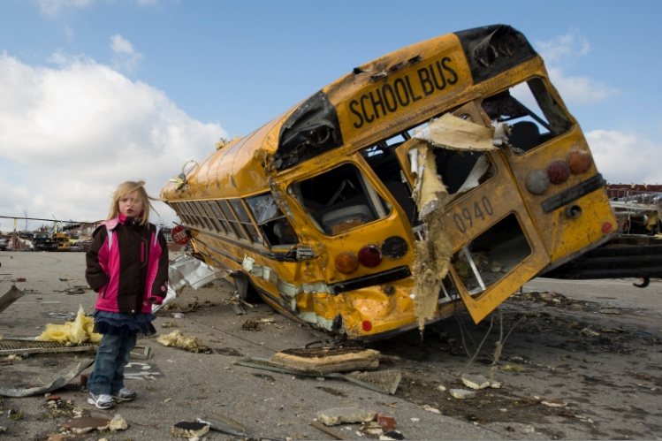
When evaluating children for PTSD, keep the following in mind:

- The potential for PTSD is especially strong among children who perceived during an event that their life was in jeopardy or who experienced intense fear, helplessness, or horror.

- Individuals with PTSD actively attempt to avoid thinking, talking about, or even remembering the event, so symptoms may not become evident to others for months (or longer) without active screening or outreach.[7]

Footnotes:
7 Schonfeld D, Gurwitch R. Children in disasters. In: Elzouki AY, Stapleton FB, Whitley RJ, Oh W, Harfi HA, Nazer H, eds. Textbook of Clinical Pediatrics, 2nd ed. New York, NY: Springer-Verlag; 2011: 687-698.
Graphic = NC_PI_T02_050
ALT tag: alt="a girl walking through her elementary school parking lot in Henryville, IN after the town was devastated by a large tornado in March 2012"
Photo caption: n/a
Photo credit: U.S. Army photo by Sgt. John Crosby/Released
Screen Prompt: Click Next to continue.
Programmer Notes / Interactions & Feedback: This screen contains text and a photo right-aligned with the text.

